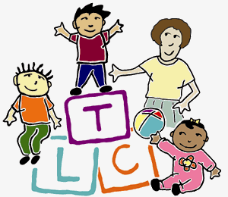

Teaching and Learning Collaborative
130 South 9th Street, Suite 600
Philadelphia, PA 19107
215.503.4020
teaching.collaborative@jefferson.edu

Provider Competency: Application of Tier 1 strategies to promote infant and toddler social emotional development

Provider name: Date:

Family 1: Child’s initials: Date of Birth:

Why is this child receiving early intervention?

Child’s diagnosis, if any

Describe the social emotional development strategies you implemented:
promoting responsive interactions | structure environment to promote regulated behavior | individualized activities
What outcomes resulted?

